# Learning Outcome

# After completing this module, the student should be Able to Build a web application on modern cloud-based architectures and services (50 Hrs)

# To meet the learning outcome, a student has to complete the following activities

1. Create Serverless functionality using AWS Lambda (10 Hrs)
2. Create multiple connected functions on AWS Lambda (10 Hrs)
3. Create serverless functionality using IBM Cloud Function (8 Hrs)
4. Create multiple connected functions on IBM Cloud Functions (8 Hrs)

# 

# Activity 1

## Aim: Create Serverless functionality using AWS Lambda

## Learning outcome: Skills on Managing application with serverless compute, DevOps and API management Services

## Duration: 10 Hours

**List of Hardware/Software requirements:**

1. Laptop or Desktop PC
2. Windows/ Linux operating system
3. Web Browser (Chrome or Firefox Mozilla)
4. AWS Account

**Code/Program/Procedure (with comments):**

**Process For Creating AWS Lambda Function**

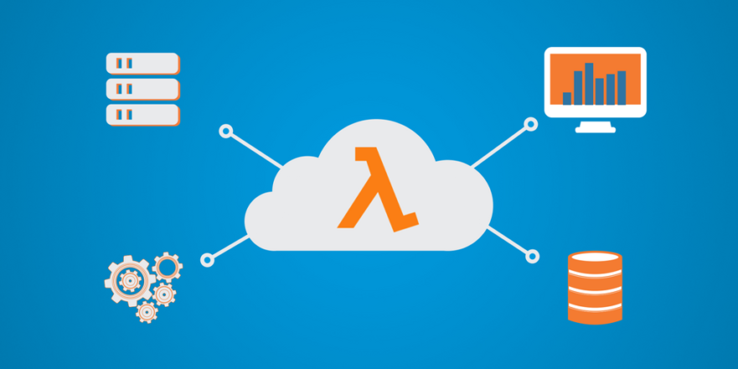

**Step 1: Login into your AWS account** and click on “Sign in to the Console.”

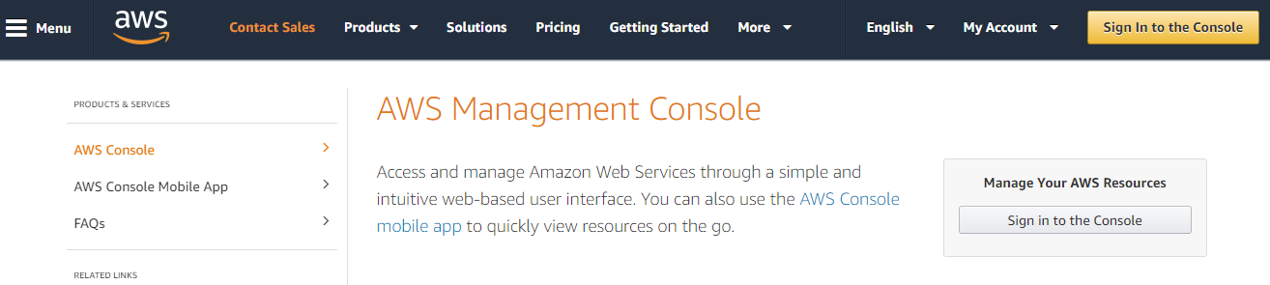

**Step 2:** Open the [**Lambda console**](https://console.aws.amazon.com/lambda)

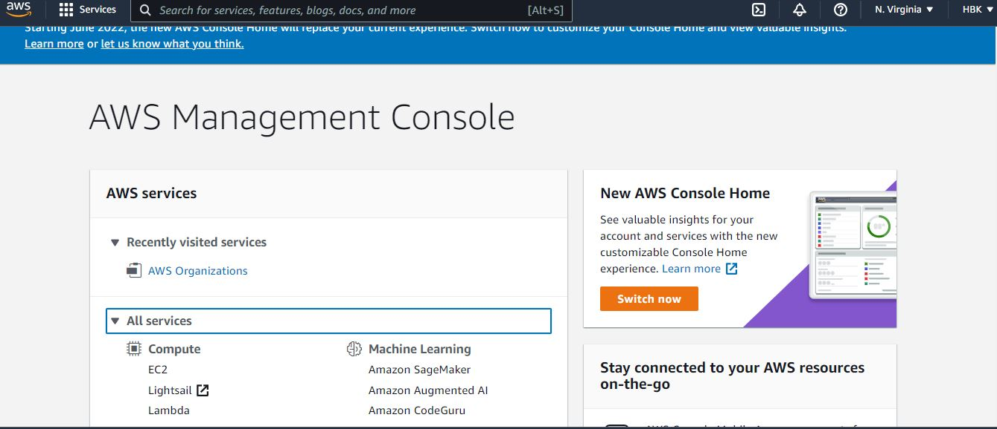

**Step 3**: Click on **“Create Function”**

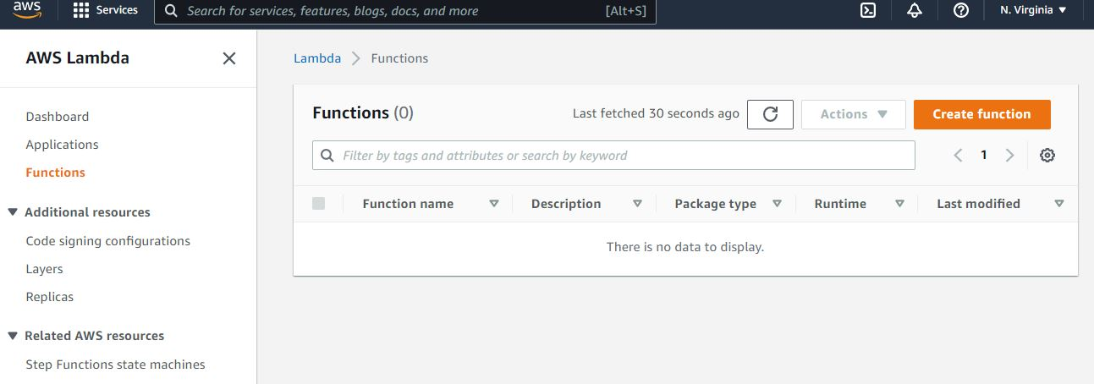

**Step 4:** Select options and click on **“Create Function”** button

Configure the following settings:

* Name – lambdaBlog
* Runtime – Python 3.9.
* Role – Choose an existing role.// Create any custom rule
* Existing Role: lambda_basic_execution

Choose Author from Scratch

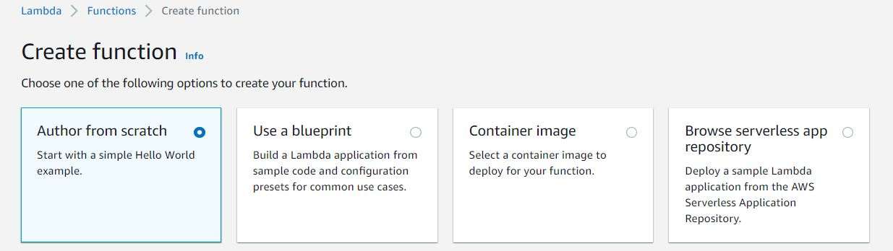

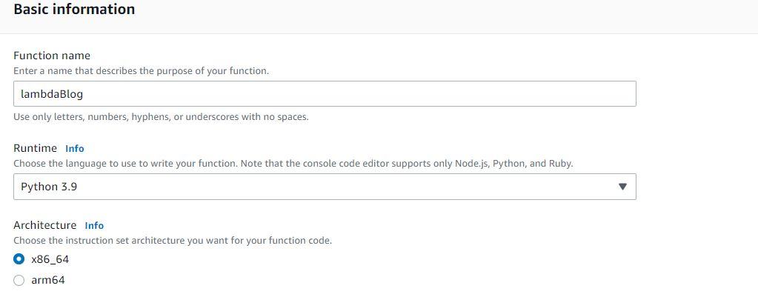

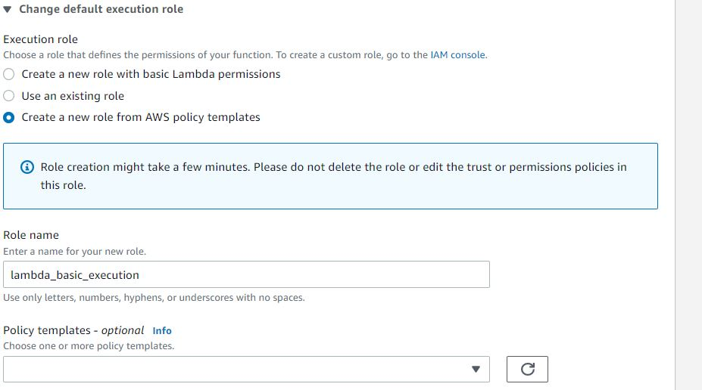

Select the Existing Role

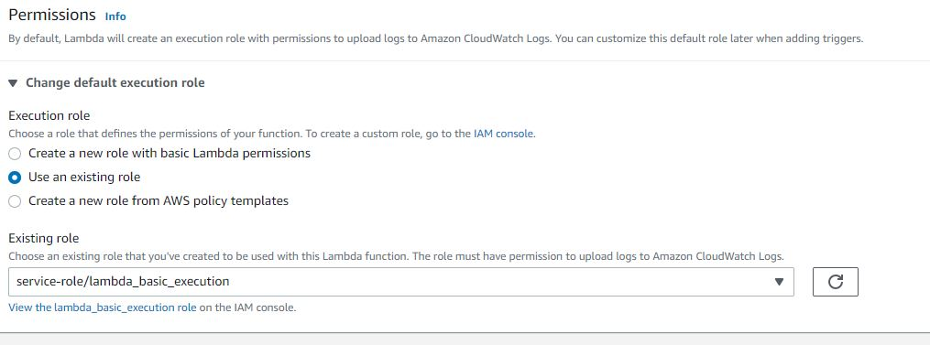

**Step 5: Lambda function created**

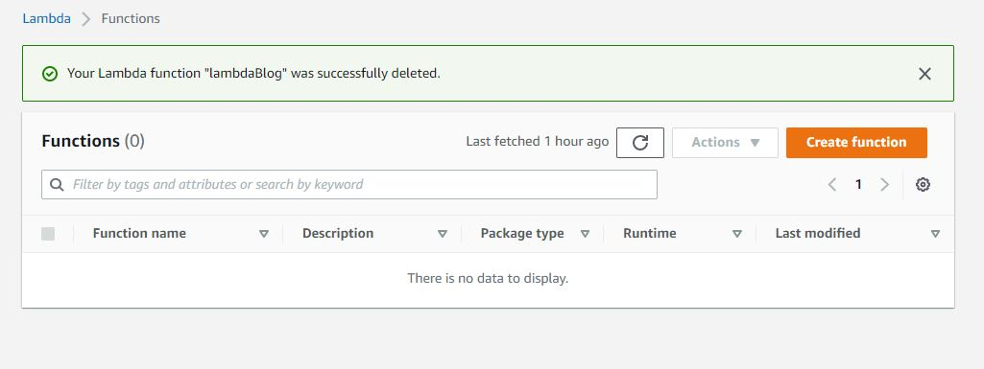

**Step 6:** Now you will be able to see the below screen. Choose a way to **upload/create** code in the lambda function.

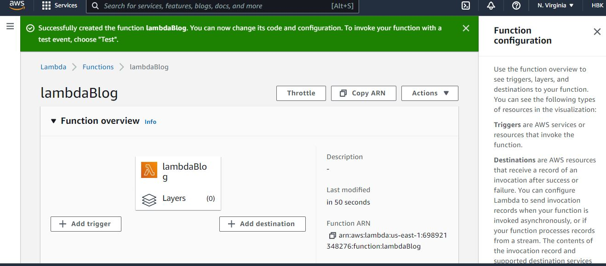

**Step 7:** Now you can write your code in the editor provided, it runs on **Python** which we selected earlier.

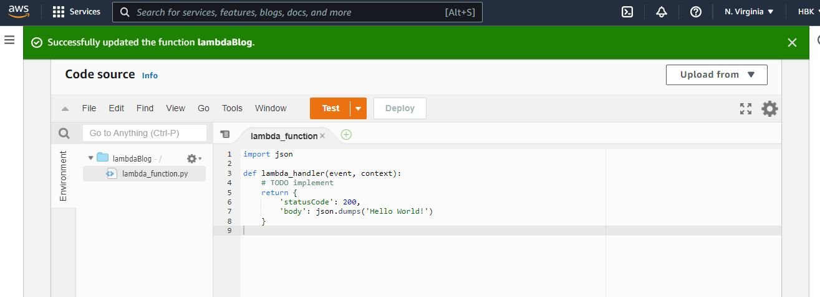

**Step 8:** Create Function **URL from the Configuration**

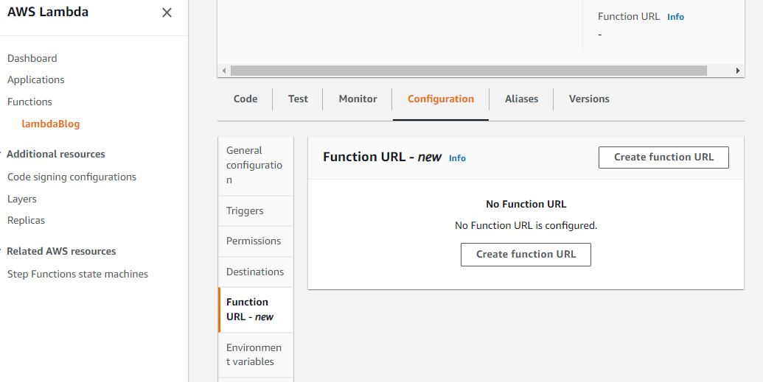

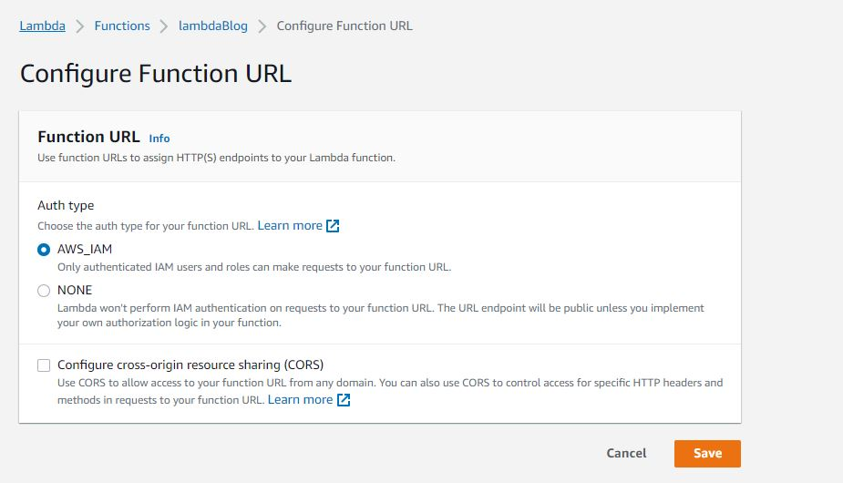

**Step 9:** We can add more options like execution **timeout, environment variables, tags** to group out our other functions, memory etc.



**Step 10:** To **configure** a test event with Event Name **->**HelloWorldEvent & choose Test.

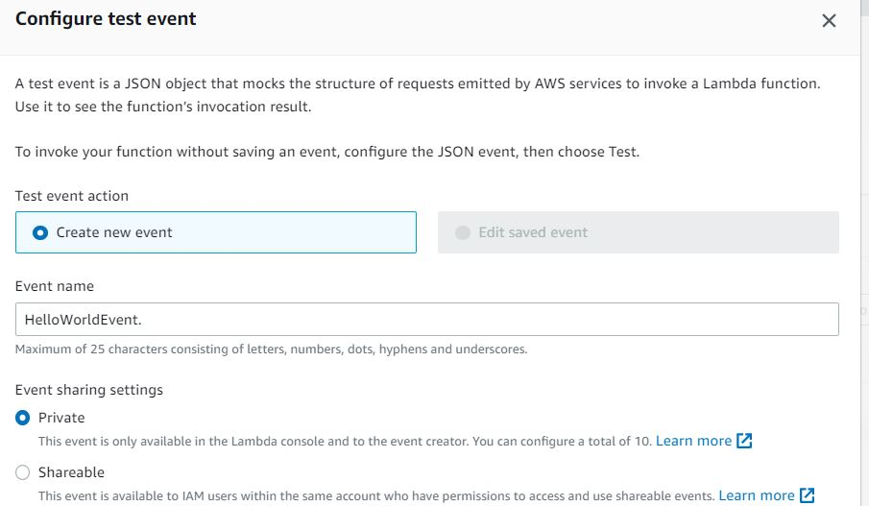

Modify the json Code

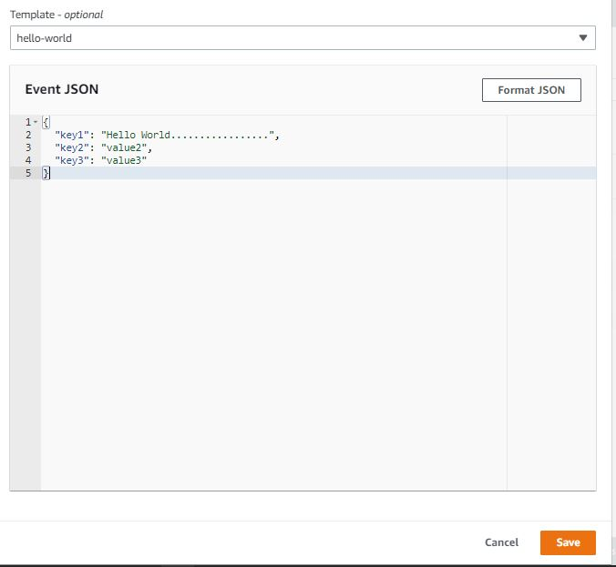

**Step 11:** To **invoke the function**, choose Test.



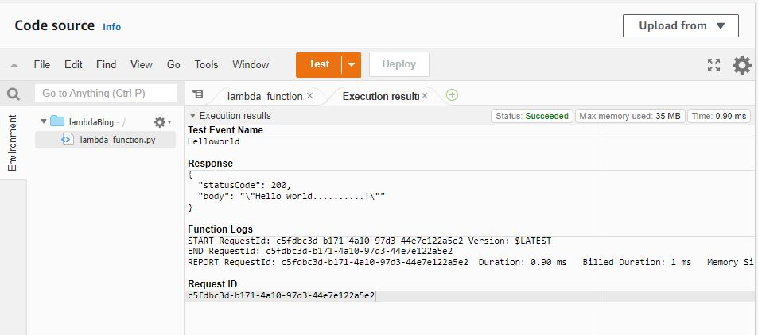

**Step 12: Execution the Code**

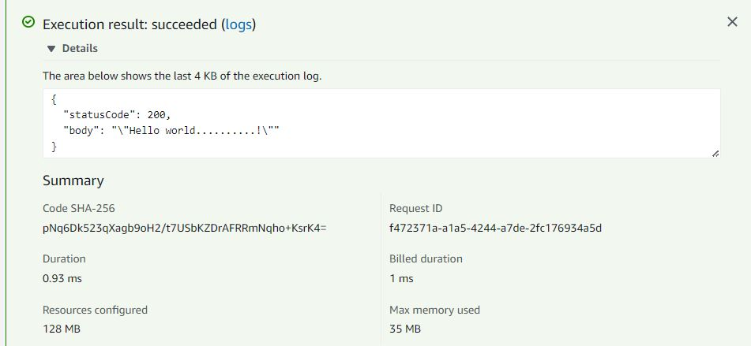

**Step13: Finally,** Copy the URL. Open a new browser window and paste the URL into the address bar You should see the result from the function.

After you’re work done Delete the Functions



**Output/Results snippet:**

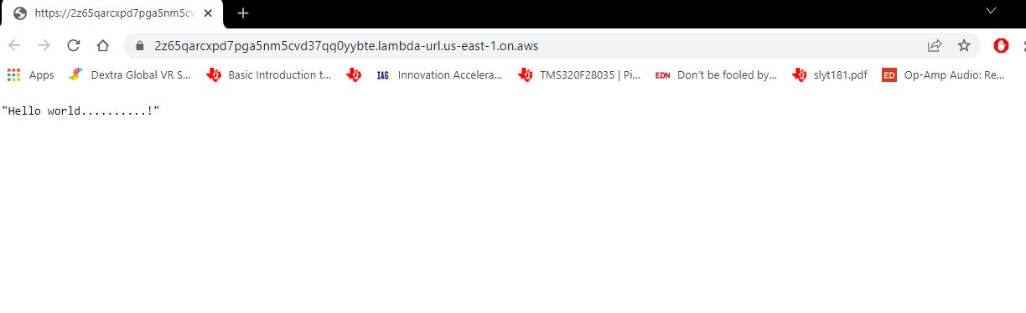

**References:**

* <https://docs.aws.amazon.com/lambda/latest/dg/lambda-python.html>

# Activity 2

## Aim: Create multiple connected functions on AWS Lambda

## Learning outcome: Skills on Managing application with serverless compute, DevOps and API management Services

## Duration: 10 Hours

**List of Hardware/Software requirements:**

1. Laptop or Desktop PC
2. Windows/ Linux operating system
3. Web Browser (Chrome or Firefox Mozilla)
4. AWS Account

**Code/Program/Procedure (with comments):**

**Process For Creating AWS Lambda Multiple connected Function**



**Step 1: Login into your AWS account** and click on “Sign in to the Console.”



**Step 2:** Open the [**Lambda console**](https://console.aws.amazon.com/lambda)



**Step 3**: Click on **“Create Function”**



**Step 4:** Select options and click on **“Create Function”** button

Configure the following settings:

* Name – Serverless
* Runtime – Python 3.9.
* Role – Choose an existing role / Create any custom rule
* Existing Role: lambda_basic_execution / ServerlessRole

Similar to one more Function

* Name – ServerlessParam
* Runtime – Python 3.9.
* Role – Choose an existing role / Create any custom rule
* Existing Role : ServerlessRole

Choose Author from Scratch



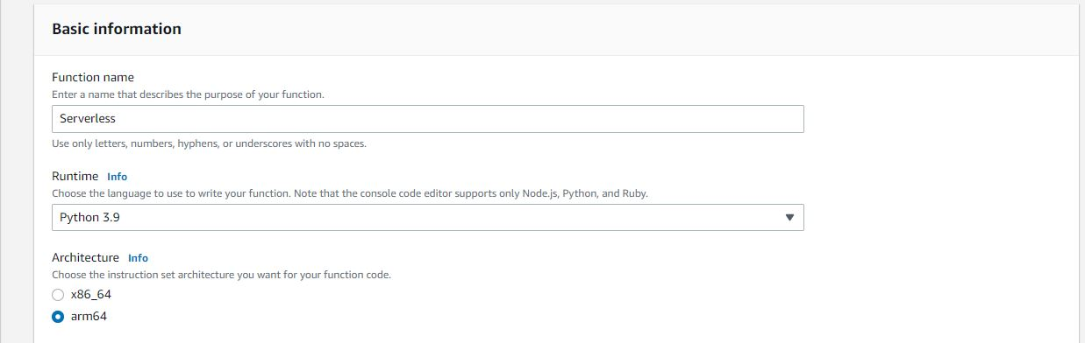

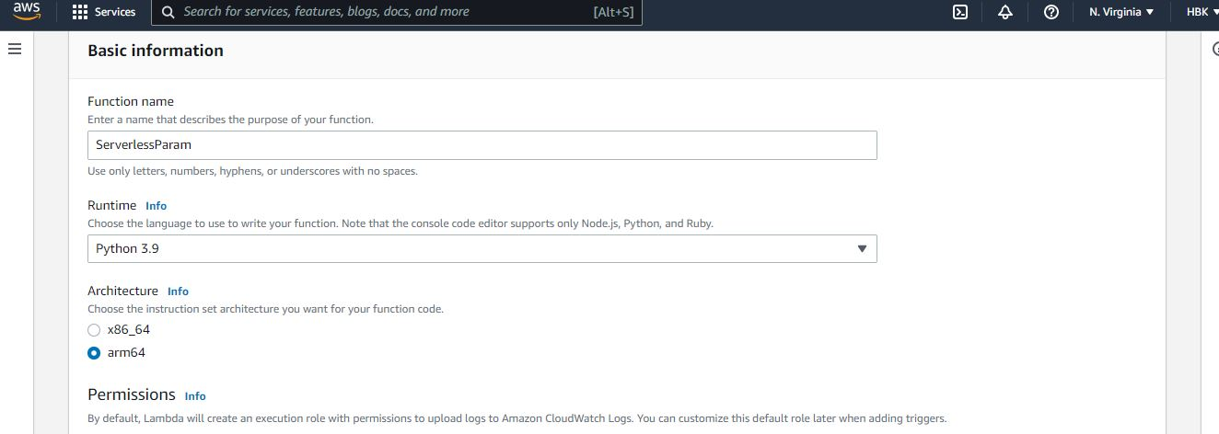

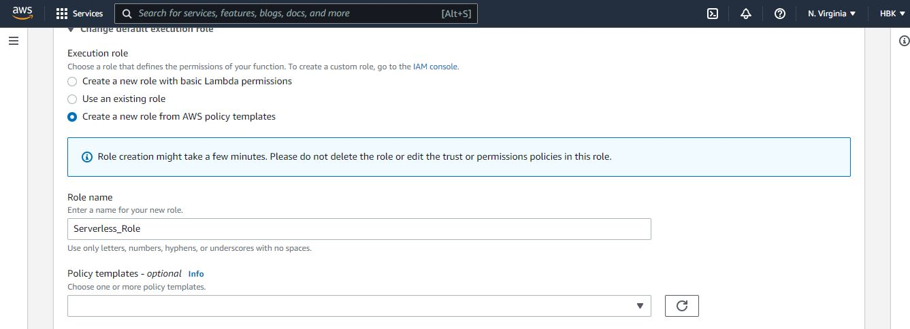

Select the Existing Role

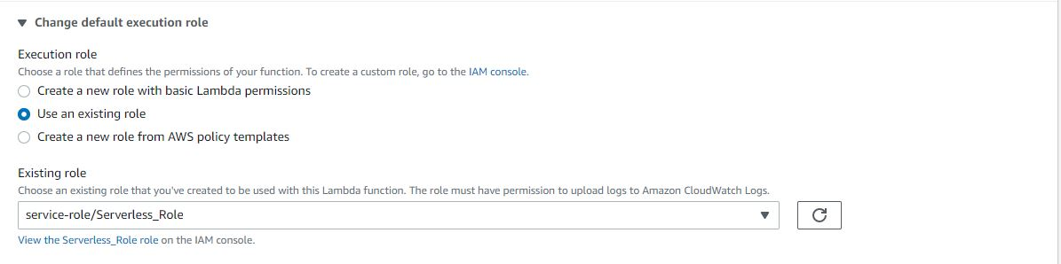

**Step 5: Lambda function created.** Now you will be able to see the below screen. Choose a way to **upload/create** code in the lambda function.



**Step 6:** Now you can write your code in the editor provided, it runs on **Python** which we selected earlier.

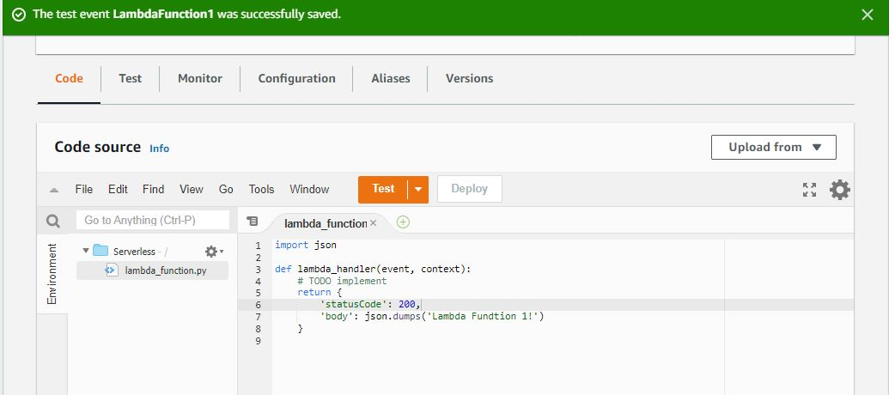

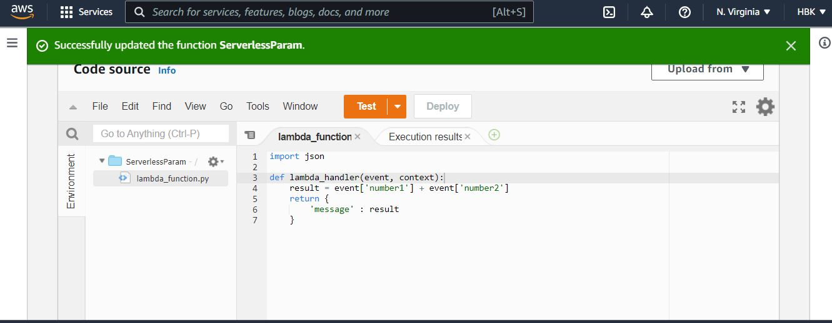

List out the 2 Lambda Functions

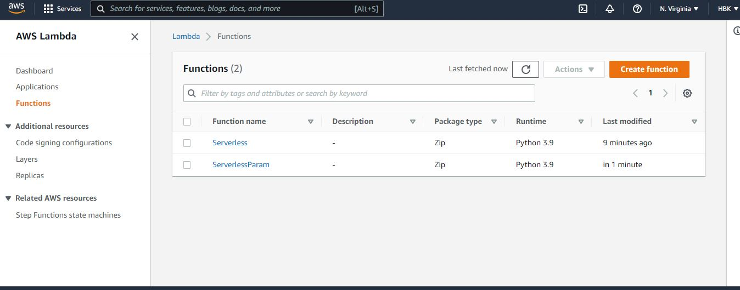

**Step 7:** Create Function **URL from the Configuration**

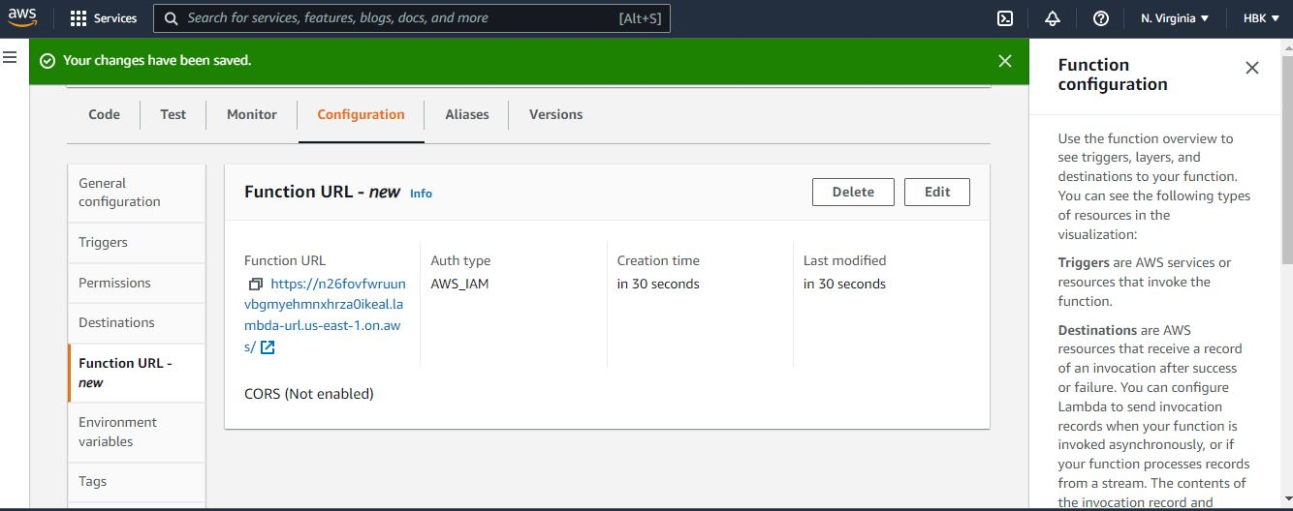

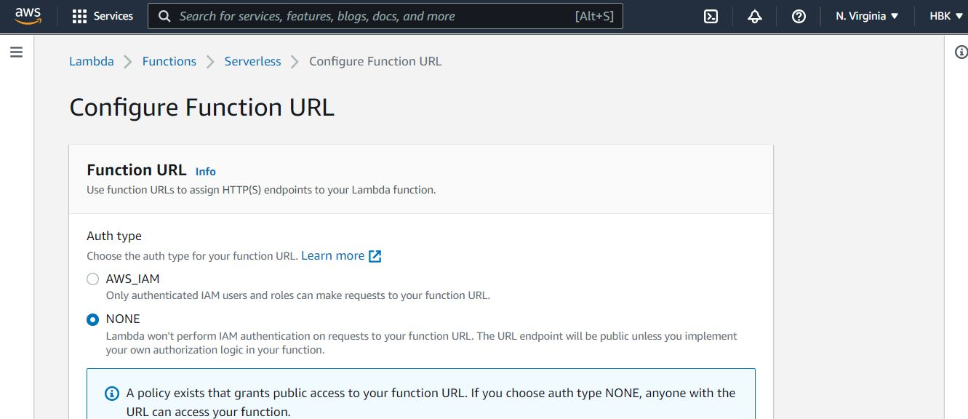

**Step 8:** We can add more options like execution **timeout, environment variables, tags** to group out our other functions, memory etc.



**Step 9:** To **configure** a test event with Event Name ->LamdaFunction1, LambdaParam & choose Test.

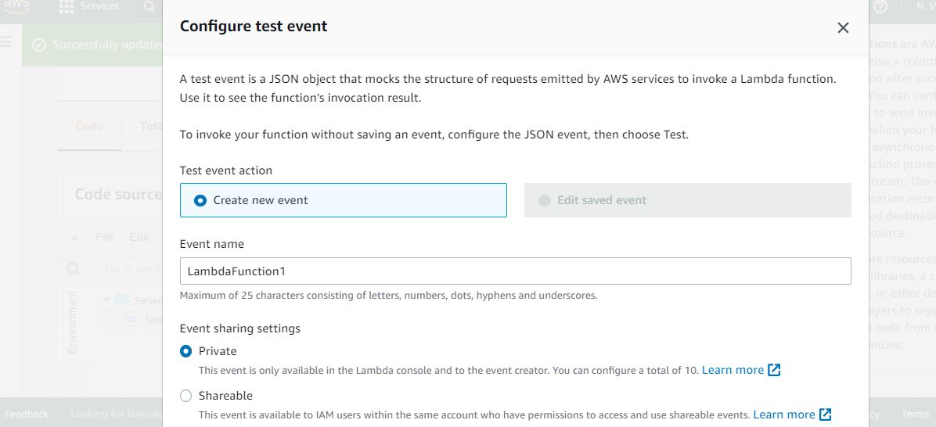

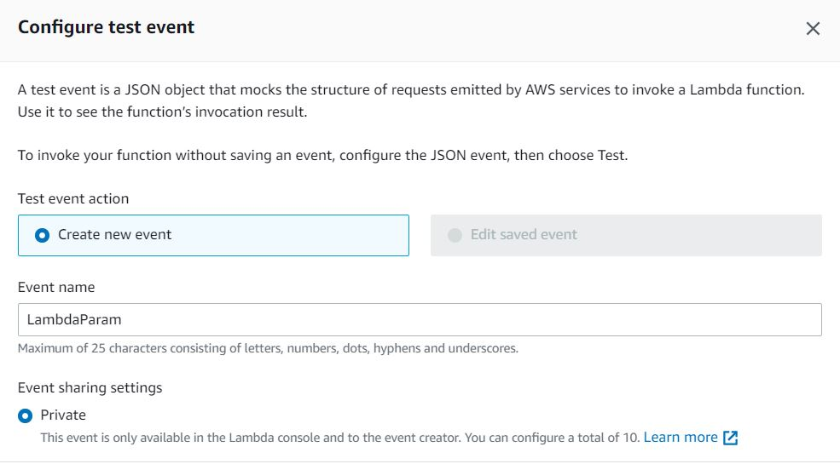

Modify the json Code

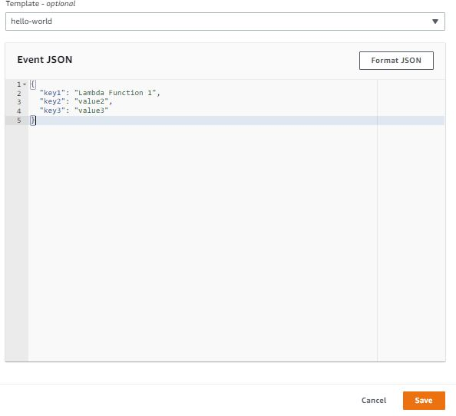

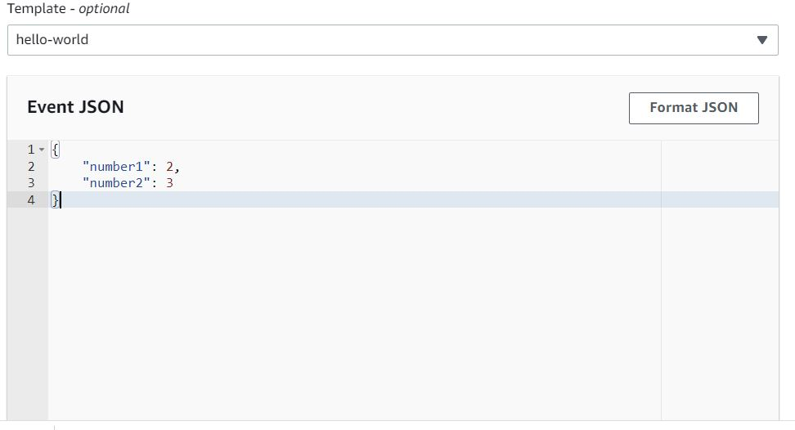

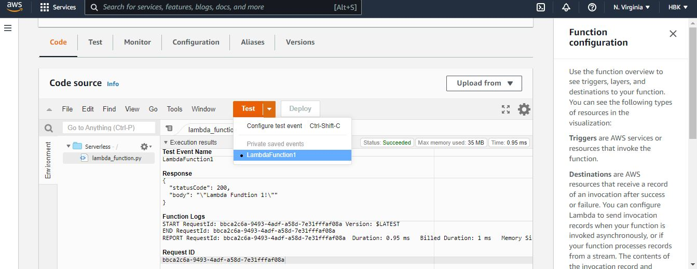

**Step 10:** To **invoke the function**, choose Test.



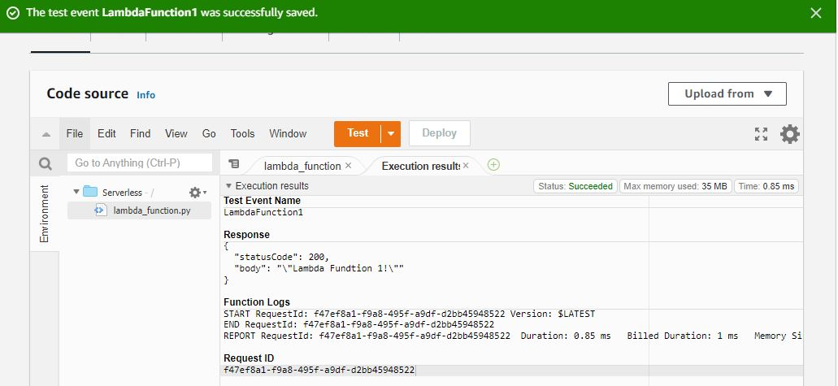



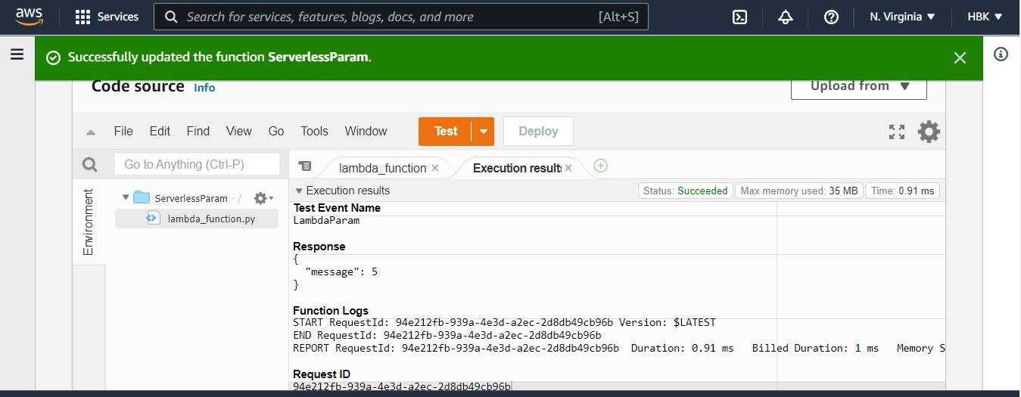

**Step 11: Execution the Code**

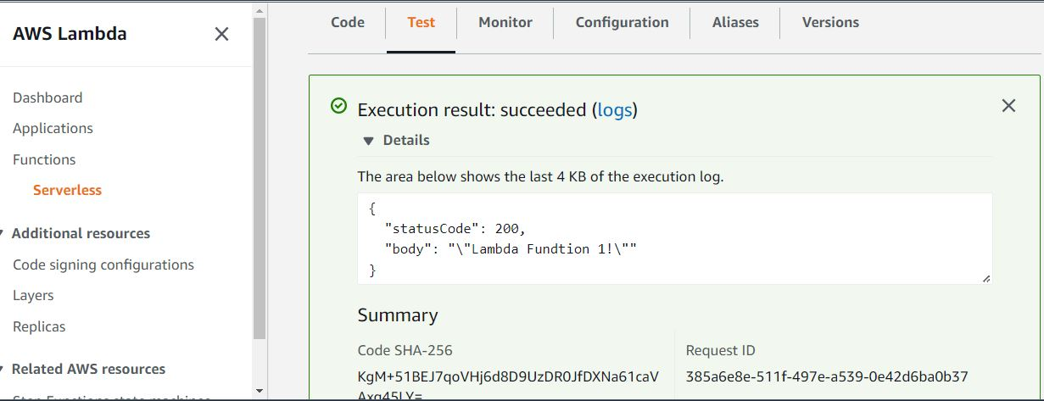

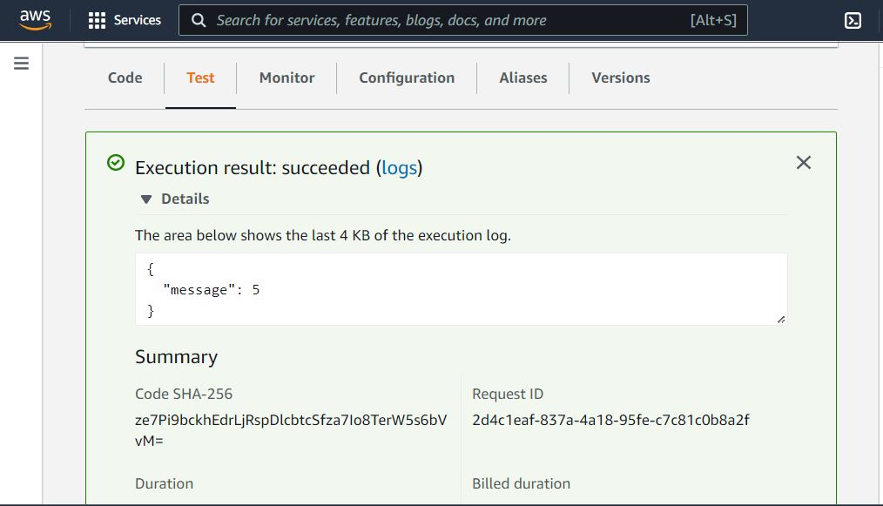

**Step12: Finally,** Copy the URL. Open a new browser window and paste the URL into the address bar You should see the result from the function.

After you’re work done Delete the Functions

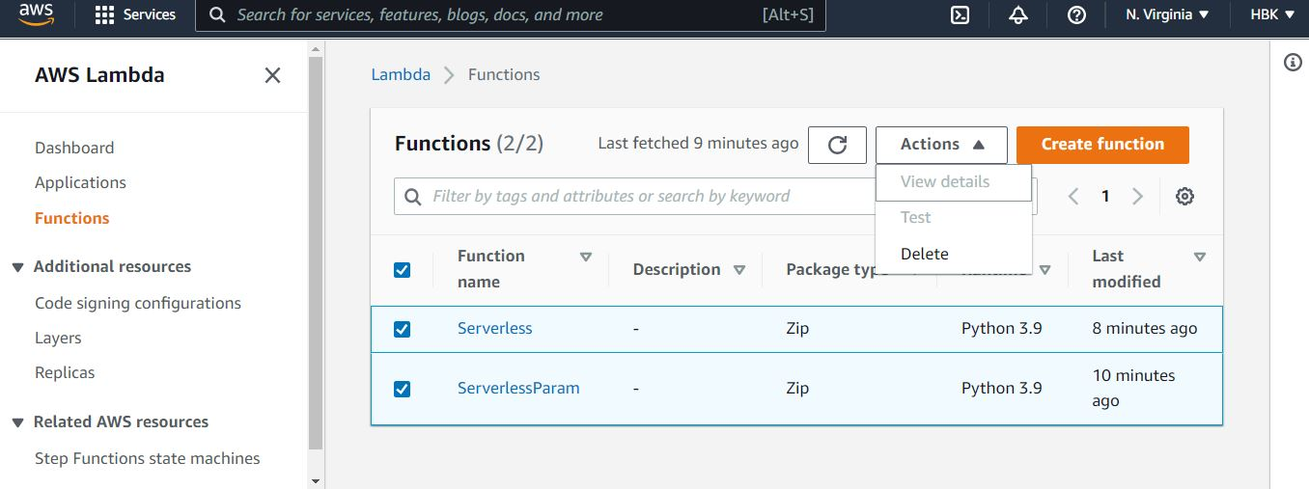

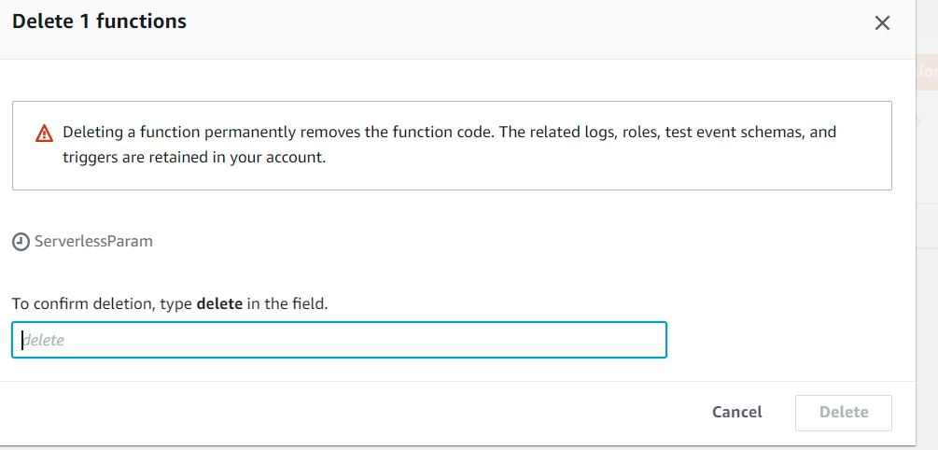

**Output/Results snippet:**

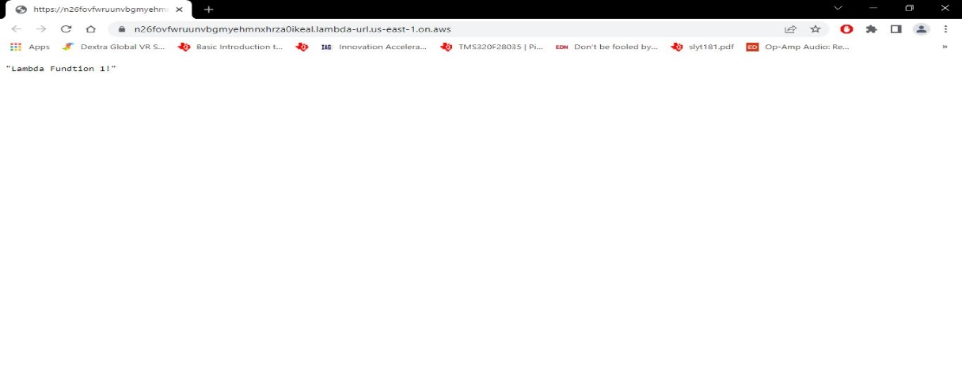



**References:**

* <https://docs.aws.amazon.com/lambda/latest/dg/lambda-python.html>

# Activity 3

## Aim: Create serverless functionality using IBM Cloud Function

## Learning outcome: Skills on Managing application with serverless compute, DevOps and API management Services

## Duration: 8 Hours

**List of Hardware/Software requirements:**

1. Laptop or Desktop PC
2. Windows/ Linux operating system
3. Web Browser (Chrome or Firefox Mozilla)
4. IBM Cloud Account

**Code/Program/Procedure (with comments):**

You will complete the following steps:

1. Create a new IBM Cloud account or sign into an existing account
2. Create a new cloud function
3. Test the function
4. Invoking as a REST API

**Step 1: In this first step you will sign-up for a new account or log-in into an existing account.**

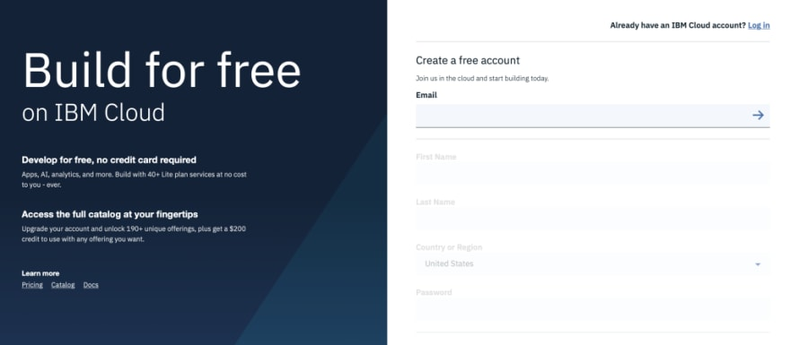

**Step 2: Creating a cloud function**

1. In this step you will create a new cloud function. After you sign-in, open the = menu in the top-right and select **Functions**.

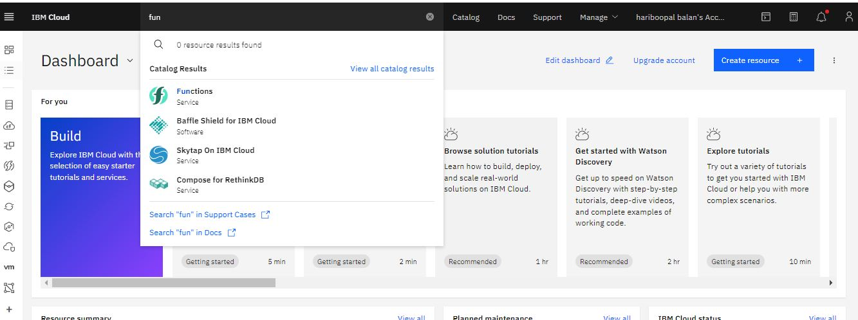

2. From the **IBM Cloud Functions** main page click **Start Creating** button

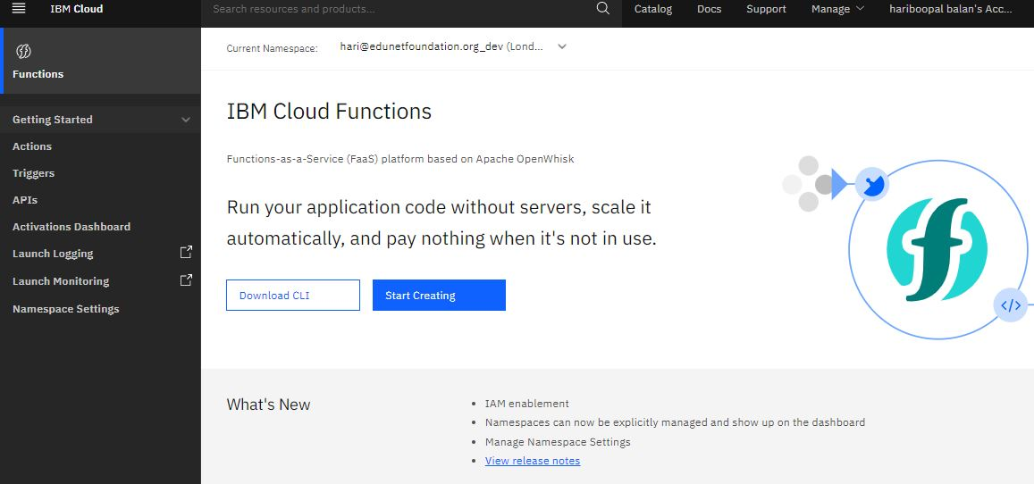

3. From the **Create** page, select **Create Action** option

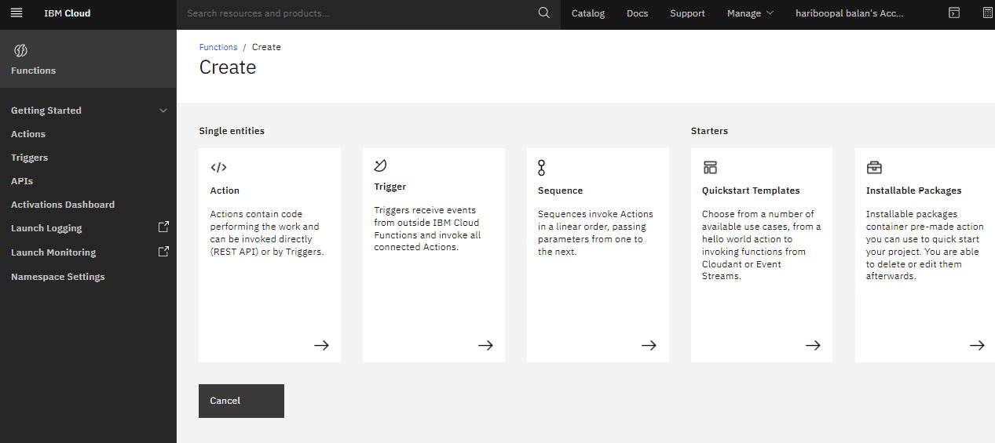

4. On the **Create Action** page

* For **Action Name** enter myfirstaction.
* Keep default values for **Enclosing Package** and **Runtime**

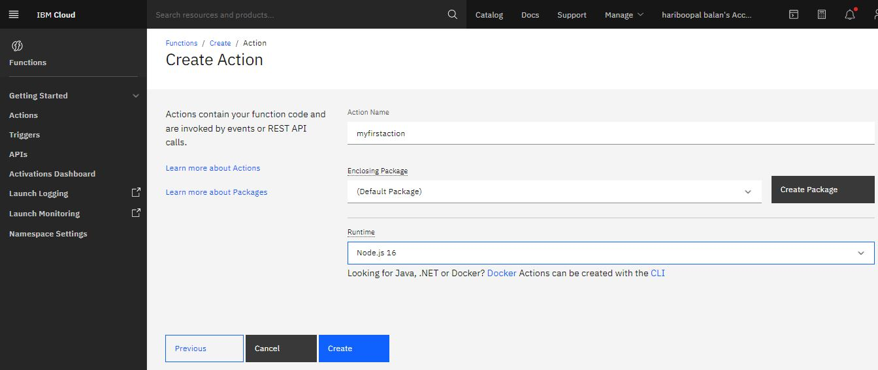

5.Click Create button to create the Serverless function. All done. You should see the function code now.

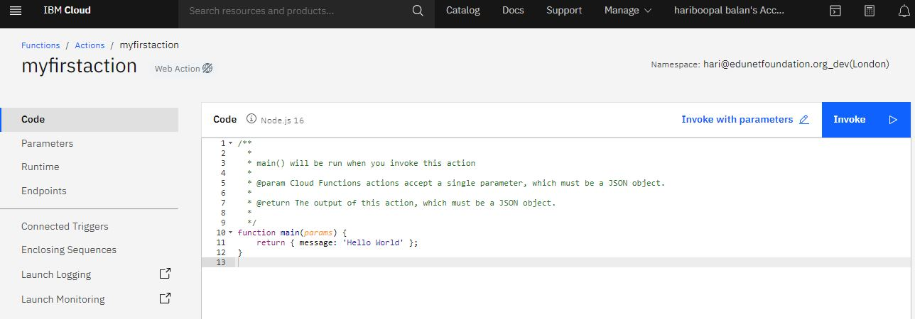

**Step 3: Testing the Function**

In this step we will test the function. To make it super simple, click the Invoke button (upper right). You are done.

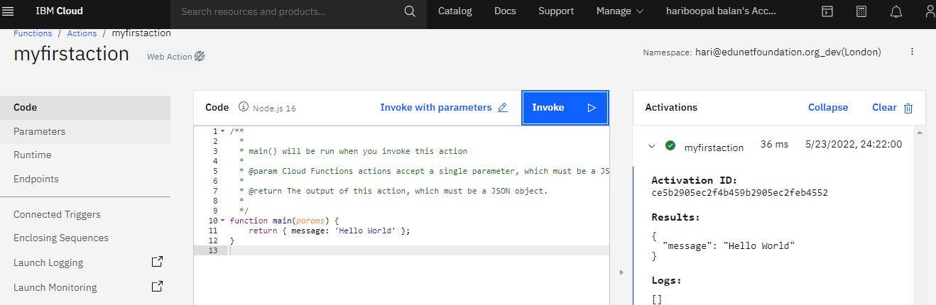

Now, to make it just a little bit more interesting, let’s make a super small change to the function.

* Change the message the function returns to I built this in 10 minutes!
* Click the Save button
* Click the Invoke button. You should see the updated message ### Invoking as a REST API

In this last step you will learn how to invoke the function as a REST API.

* On the left-hand side menu click **Endpoints**
* In **Web Action** section, check **Enable as Web Action**. Click **Save**

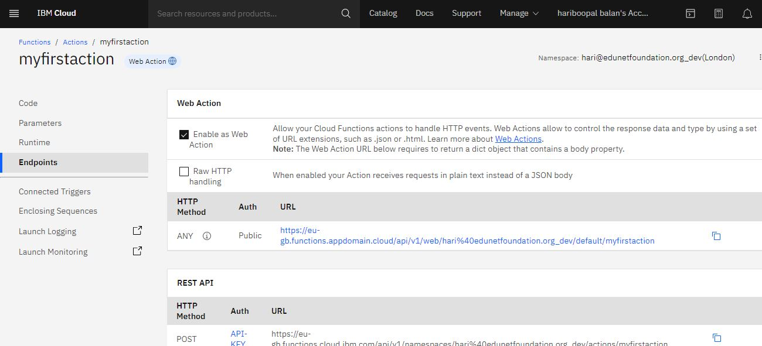

Copy the URL below. Open a new browser window and paste the URL into the address bar You should see the result from the function

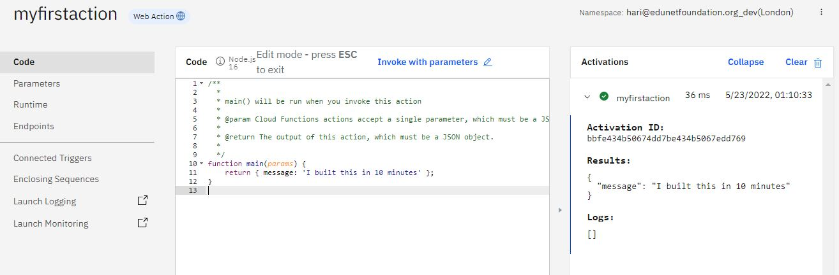

{

"message": "I built this in 10 minutes"

}

**Output/Results snippet:**

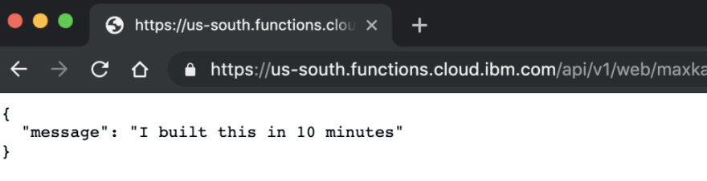

**References:**

* <https://blog.victorshinya.com.br/serverless-com-ibm-cloud-functions-como-funciona-esse-tal-serverless-f24be837b7a4>

# Activity 4

## Aim: Create multiple connected functions on IBM Cloud Functions

## Learning outcome: Skills on Managing application with serverless compute, DevOps and API management Services

## Duration: 8 Hours

**List of Hardware/Software requirements:**

1. Laptop or Desktop PC
2. Windows/ Linux operating system
3. Web Browser (Chrome or Firefox Mozilla)
4. IBM Cloud Account

**Code/Program/Procedure (with comments):**

You will complete the following steps:

1. Create a new IBM Cloud account or sign into an existing account
2. Create a new cloud function
3. Test the function
4. Invoking as a REST API

**Step 1: In this first step you will sign-up for a new account or log-in into an existing account.**



**Step 2: Creating a cloud function**

1. In this step you will create a new cloud function. After you sign-in, open the = menu in the top-right and select **Functions**.



2. From the **IBM Cloud Functions** main page click **Start Creating** button



3. From the **Create** page, select **Create Action** option



4. On the **Create Action** page

* For **Action Name** enter myfirstaction.
* Keep default values for **Enclosing Package** and **Runtime**

We have created 2 Actions**-MultiFunction1, MultiFunction2**

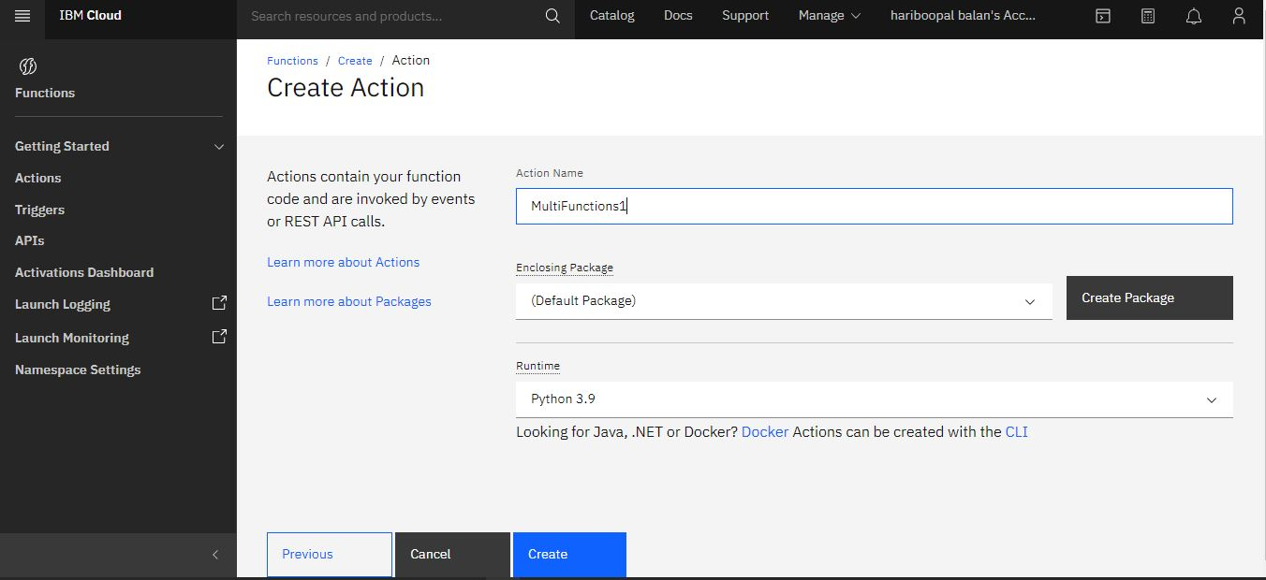

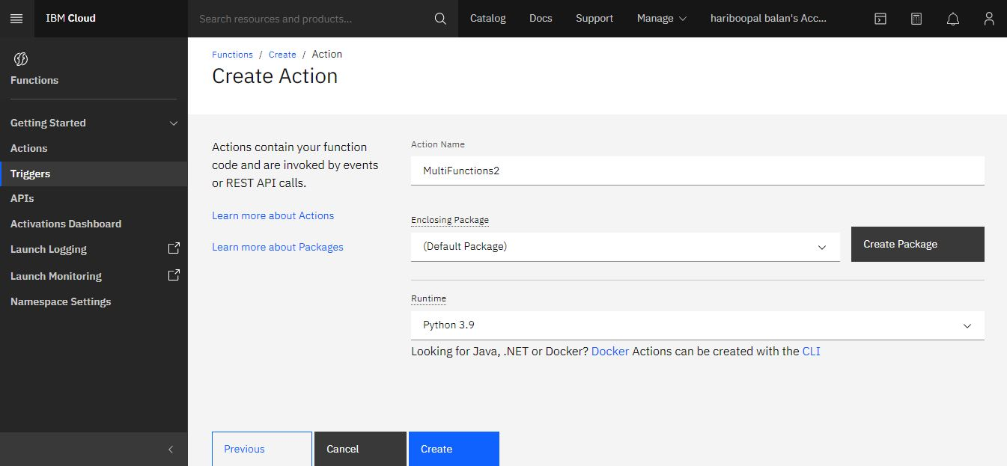

5.Click Create button to create the Serverless function. All done. You should see the function code now. **MultiFunction1,MultiFunction2**

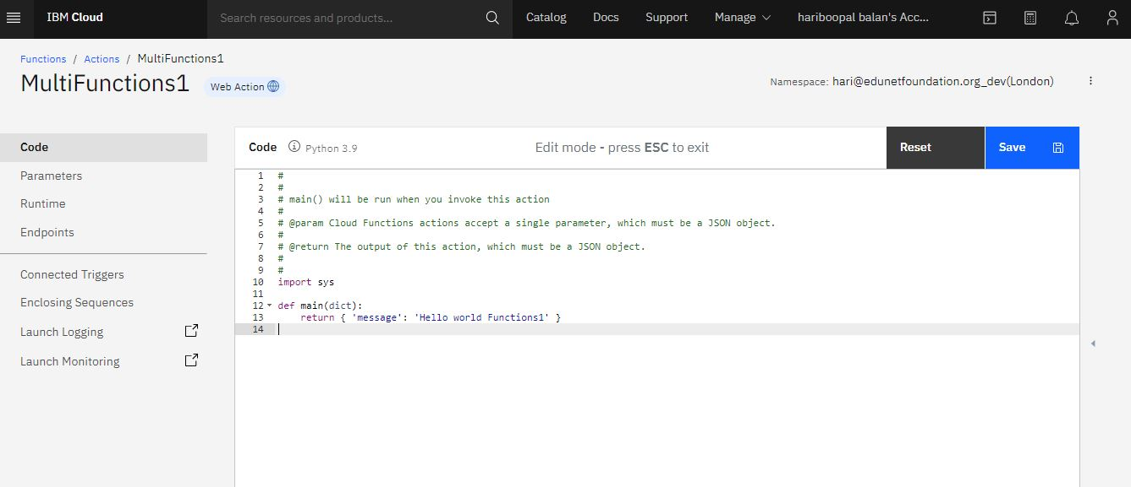

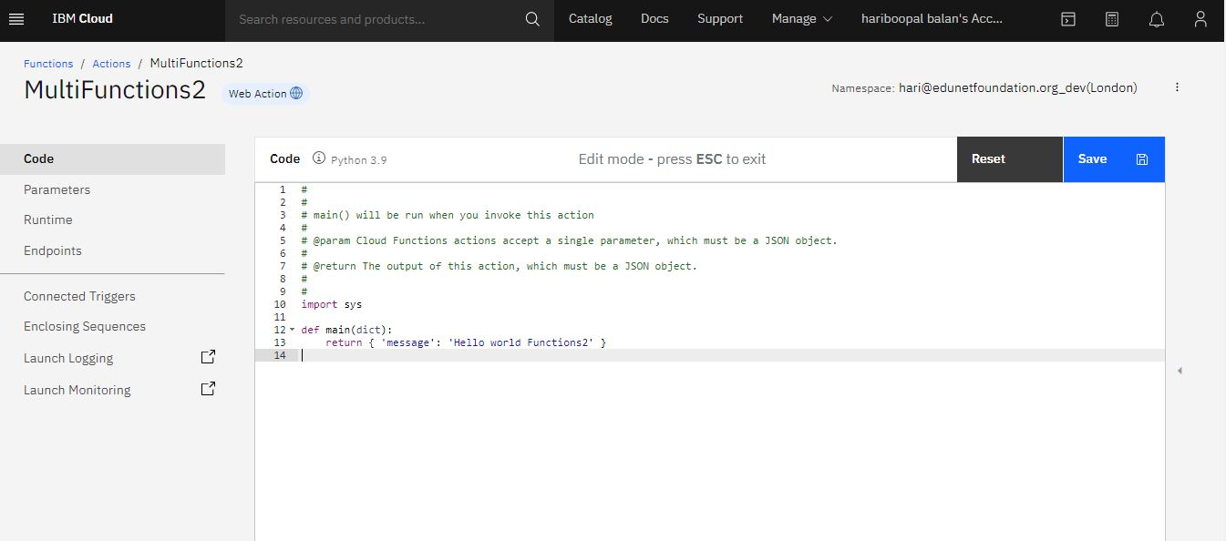

6. Invoking the Functions

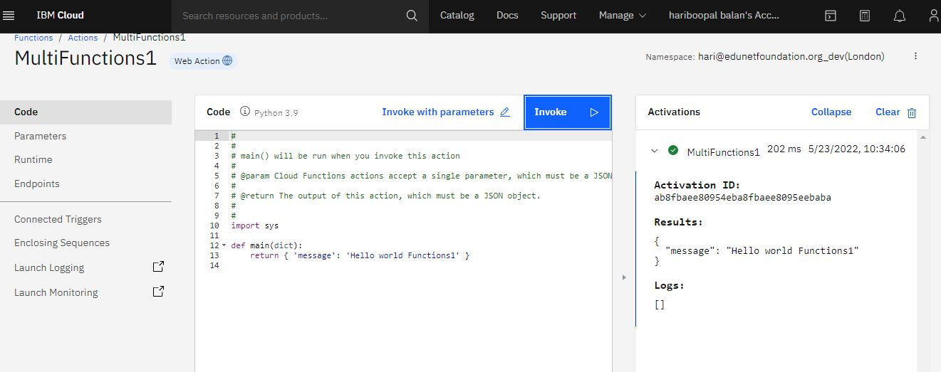

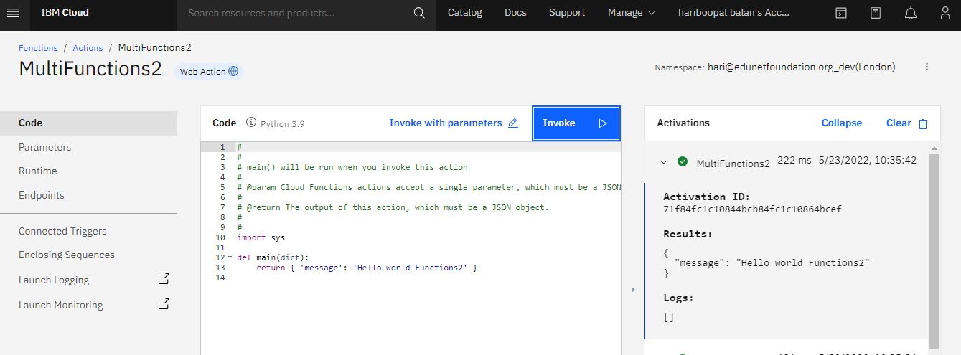

7. Click the Triggers in menu and added with multiple connected functions (Create/Existing)

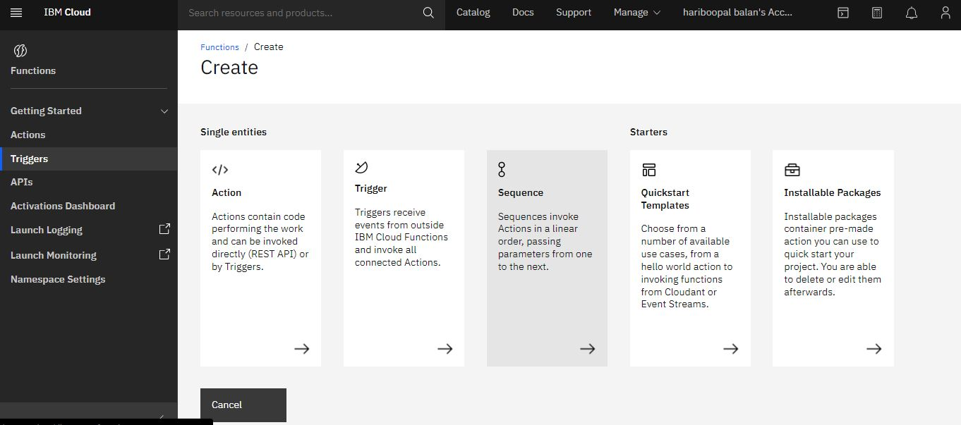

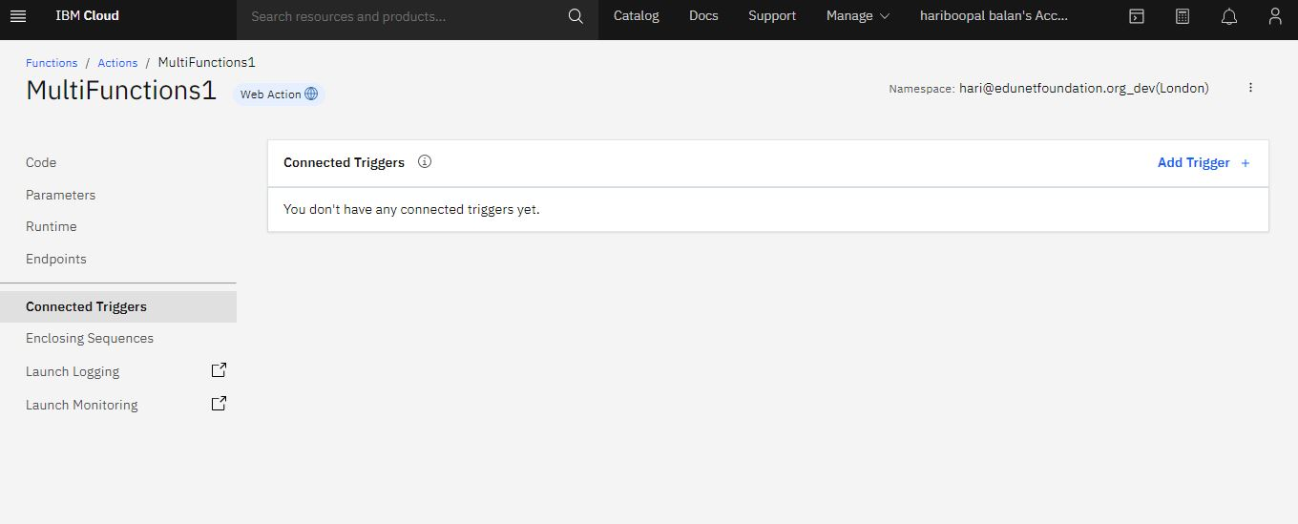

8. Click the connection Triggers and then choose from the **Trigger Type->Periodic**

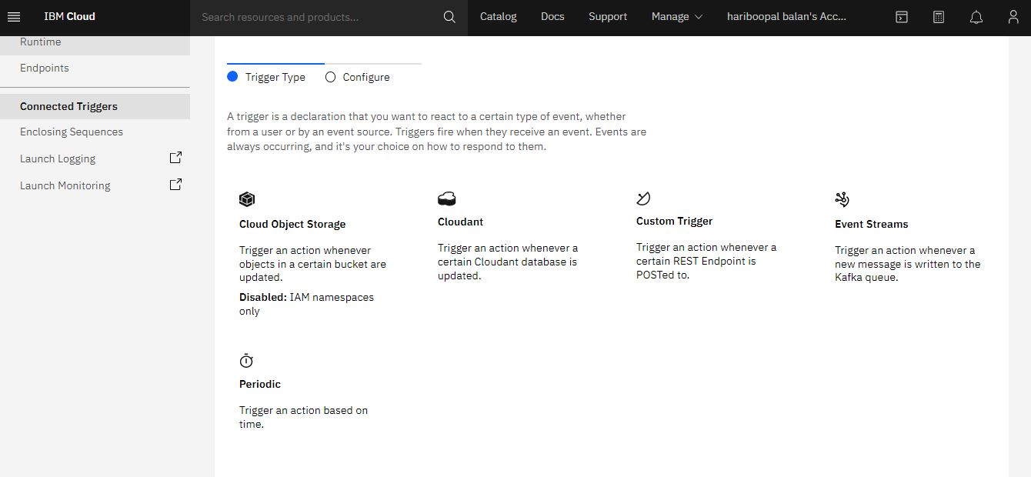

9. Tigger Name->**Demo** & Select the Pattern

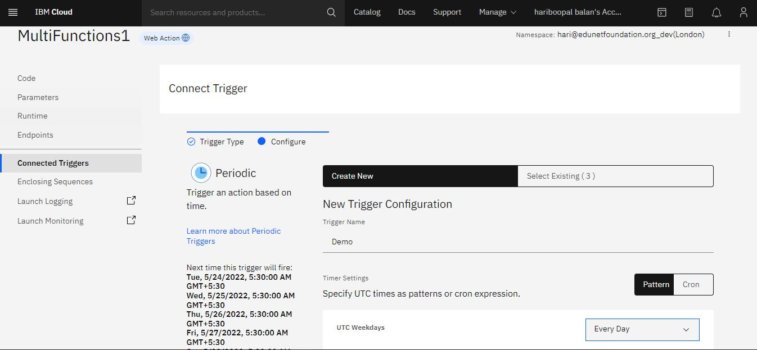

10. List out the Actions

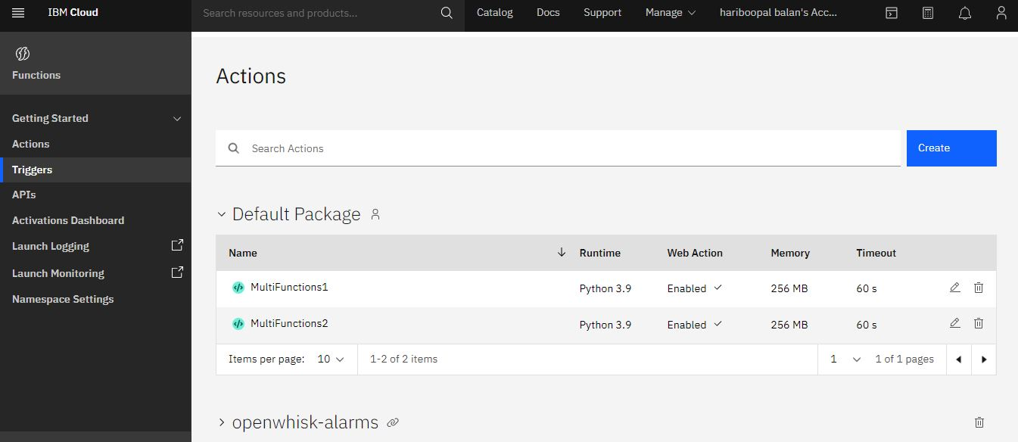

11. Existing Functions are available then choose **select Existing->MultiFunction2**

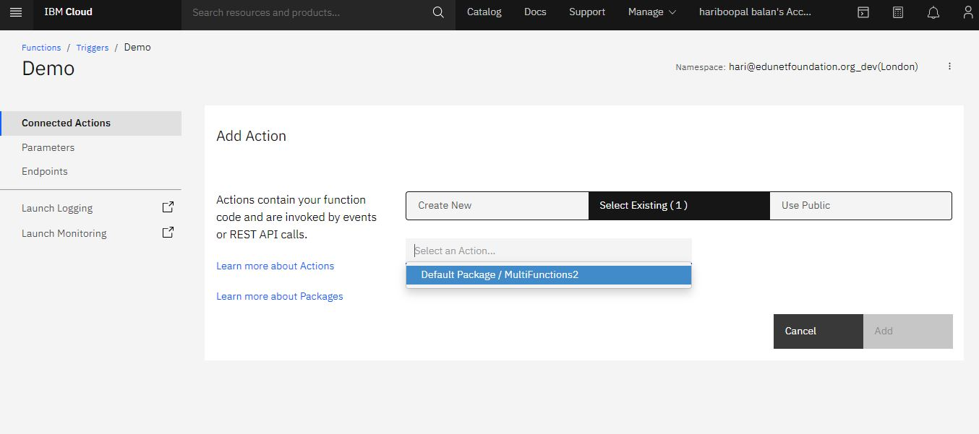

12. List out the Triggers with Actions

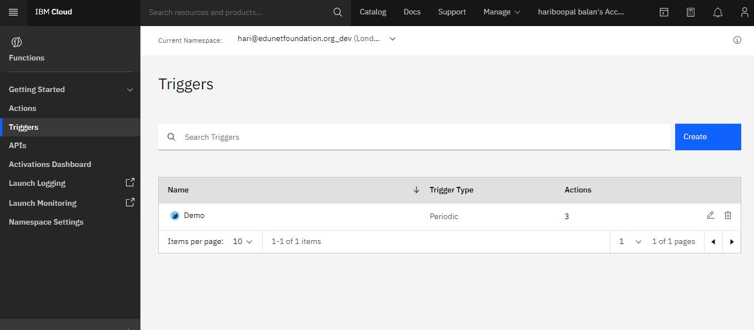

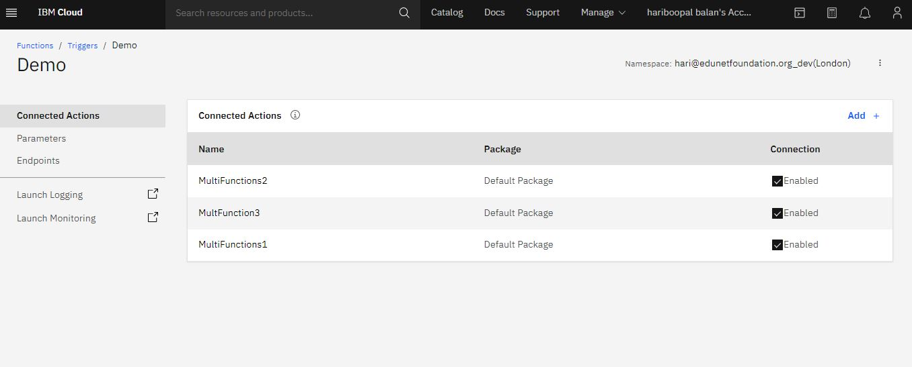

**Step 3: Testing the Function**

In this step we will test the function. To make it super simple, click the Invoke button (upper right). You are done.

Now, to make it just a little bit more interesting, let’s make a super small change to the function.

* Change the message the function returns to I built this in 10 minutes!
* Click the Save button
* Click the Invoke button. You should see the updated message ### Invoking as a REST API

In this last step you will learn how to invoke the function as a REST API.

* On the left-hand side menu click **Endpoints**
* In **Web Action** section, check **Enable as Web Action**. Click **Save**

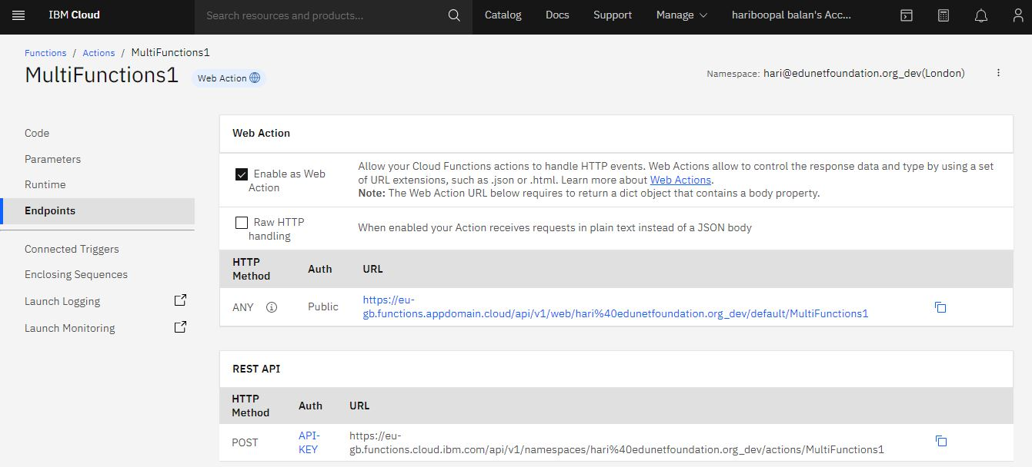

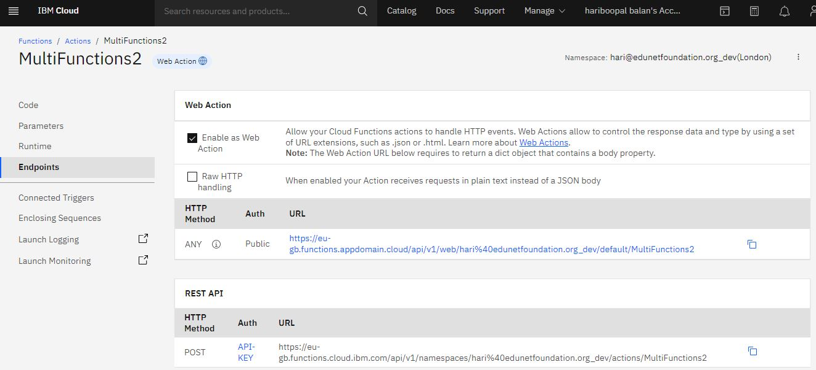

Copy the URL below. Open a new browser window and paste the URL into the address bar You should see the result from the function

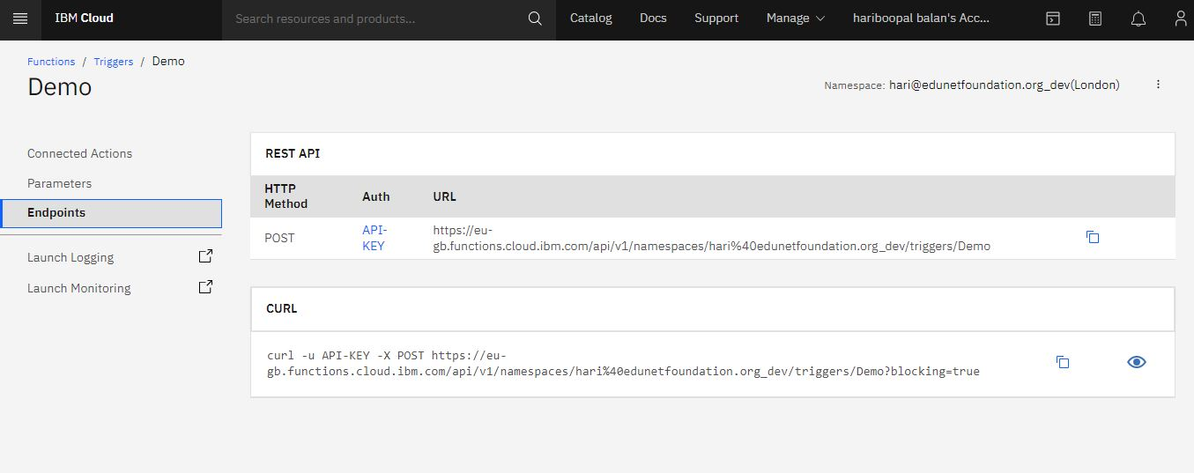

Step 4: Click the Activation Dashboard after that displays Activations Log & Summary

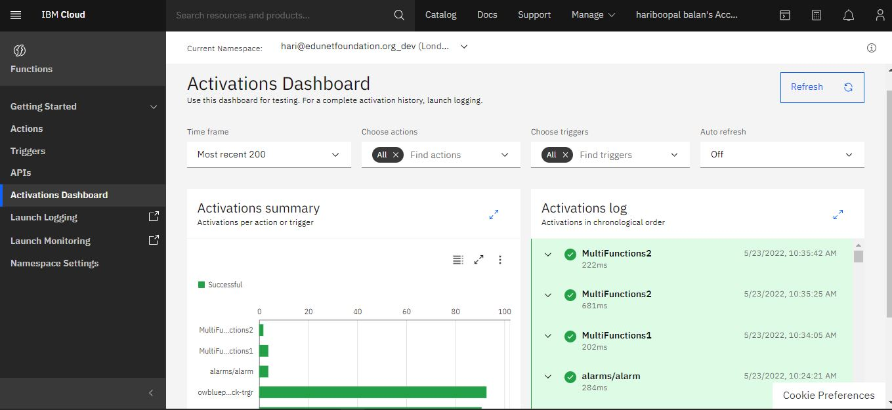

**Output/Results snippet:**





**References:**

* <https://cloud.ibm.com/functions/>